# Assignment 1: ASPCA Website

In this assignment, you will be creating a simplified version of the ASPCA website.

Learning objectives: You will practice many of the HTML tags that you have worked with. As well, you will work with CSS for the first time to style your website to mimic the screenshots included in this document.

# HTML – only

First, you will be creating the basis for this website: The HTML content that defines the page content and structure.

### Folder Setup

1. Under your “Full Stack Web Dev” folder, create a folder named: “Assignments”
2. Under your “Assignments” folder, create a folder named: “assignment1”
3. Under your “assignment1” folder, create 1 html file:
   1. index.html
4. Under your “assignment1” folder create a folder named “html.” Then, create the 3 html files below:
   1. key_issues.html
   2. our_response.html
   3. how_you_can_help.html
5. Starting with the index.html page, include the HTML elements listed below. Your page will look *something* like the screenshots shown below. *(It’s okay if it doesn’t look exactly like the screenshot—we’ll fix this when we get to adding CSS styling!)*

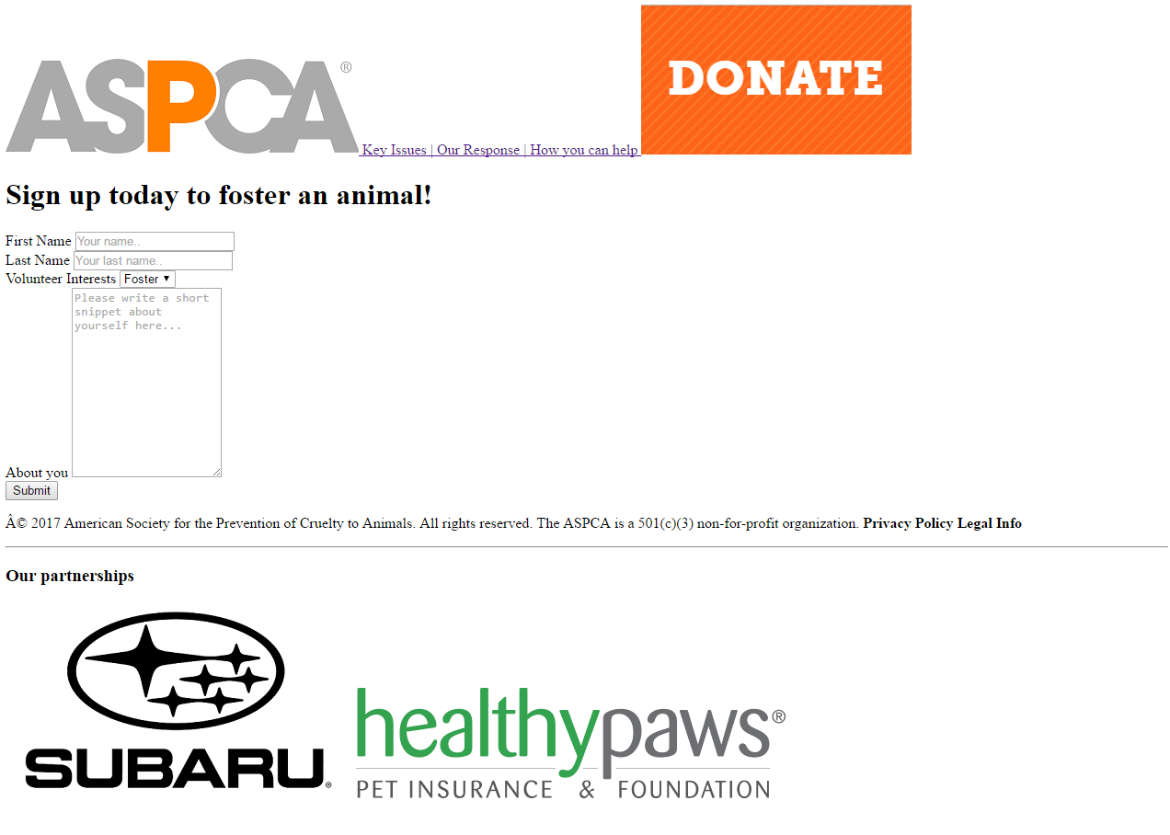**index.html:**

**Page 1: index.html. Contains**:

1. Navigation section with two images and 3 links to relative sites.
   1. When clicked, the ASCPA image should link to “index.html”
2. One <h1> heading tag.
3. A Signup form with the shown labels, 2 text fields, one dropdown box (with the 3 options: Foster, Adopt, and Other), and a larger text area. Be sure to include placeholder text where shown. A submit button.
4. A footer containing:
   1. Website information
   2. A horizontal rule: <hr>
   3. An <h3> tag
   4. Two images shown above.
   5. Symbols for footer: © Â. See [w3schools Character Sets Reference](http://edcc.edu/w3schools/tags/ref_charactersets.html) for more symbols.

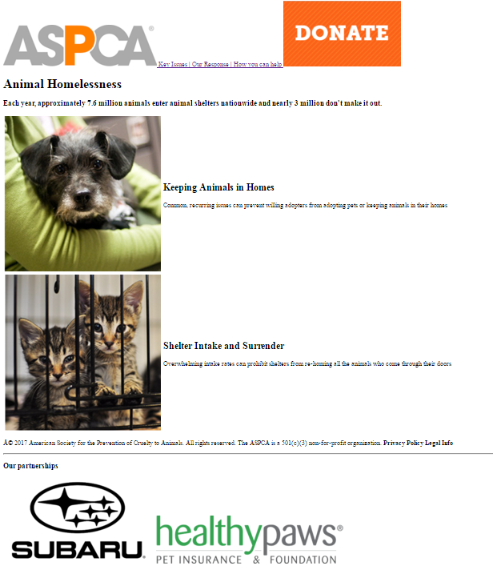**key_issues.html:**

**Page 2: key_issues.html contains:**

1. The same navigation content as index.html.
   1. Tip: you can just copy the content include in your index.html <nav></nav> tags!
2. An <h1> heading tag.
3. A <h3> heading tag.
4. A table with 2 rows and 2 columns containing the shown images and text.
5. The same footer content as index.html
   1. Tip: you can just copy the content include in your index.html <footer></footer> tags!

**our_response.html:**

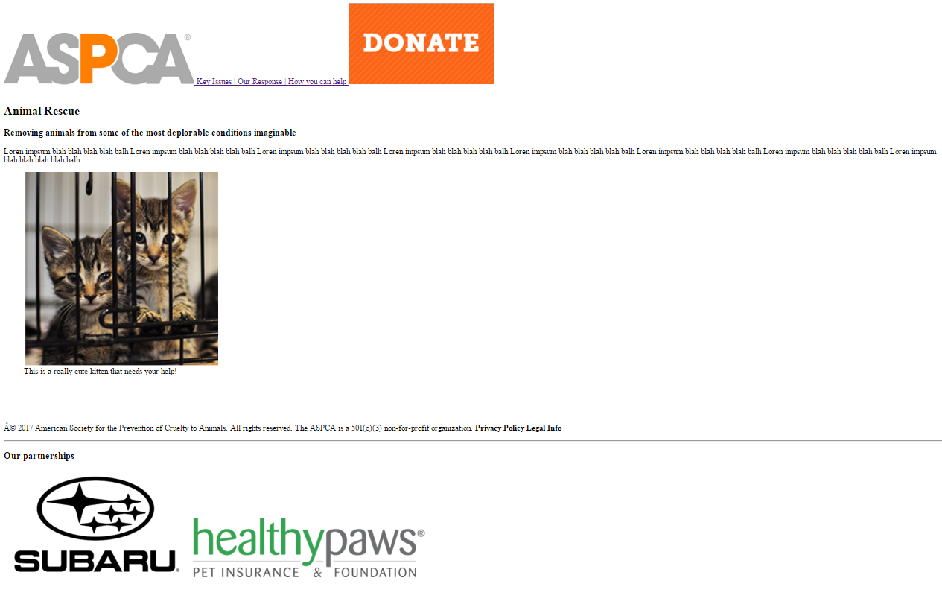

**Page 3: our_response.html contains:**

1. The same navigation section as index.html
2. An <h1> heading tag
3. An <h3> heading tag
4. A paragraph with text of your choice.
5. A figure containing an image and a figure caption.
6. The same footer as index.html

**how_you_can_help.html:**



Page 4 content of your choice



**Page 4: how_you_can_help.html contains:**

1. The same navigation section as index.html
2. Your choice of html elements.
3. The same footer as index.html

# Adding CSS Styling!

## Prior to beginning this section:

**Validate all 4 of your html files!**

**Confirm that your html files conform to the class** **Web Development Style Guide****!**

## Read [CSS basics](http://edcc.edu/marksheet/css-basics.html) in Marksheet Reference.

## Read [CSS Text](http://edcc.edu/marksheet/css-text.html) in Marksheet Reference

## Read [CSS Box-model](http://edcc.edu/marksheet/css-box-model.html) in Marksheet Reference

Basic CSS properties used:

Body:

* Align text center of page
* Change width of body to 80%
* Font family is Calibri
* Margin on the left hand side is 10%
  + **Reference your textbook on page 314 for more on margins.**

Navigation:

* Change height of images
* Change color of text (color: orange;)
* Take away underlining from links (text-decoration: none;)
* text-align: center

Sign-up form:

* background-color: #f2f2f2; **(IF THIS COLOR IS NOT SHOWING UP WELL ON YOUR MONITOR, CHOOSE ANOTHER COLOR OF YOUR CHOICE on** [w3school’s Color Picker page](http://edcc.edu/w3schools/colors/colors_picker.html)**.)**
* padding 20px on: top, bottom, left and right hand sides;
  + **Reference your textbook on page 313 for more on padding.**
* Align text center (text-align: center;)
* Read w3school’s reference on [CSS Forms](http://edcc.edu/w3schools/css/css_form.html) for form input styling.

Footer:

* Re-sizing images

Partnerships section:

* background-color: orange;

**NOTE: YOUR WEBSITE WILL BE GRADED ON HOW IT APPEARS IN FULL-SCREEN MODE. We will talk about “responsive design” in the coming days.**

Development tip: Begin with your html layout first, then work on your CSS styling. Every change you make, be sure to refresh your browser and view your updated website!

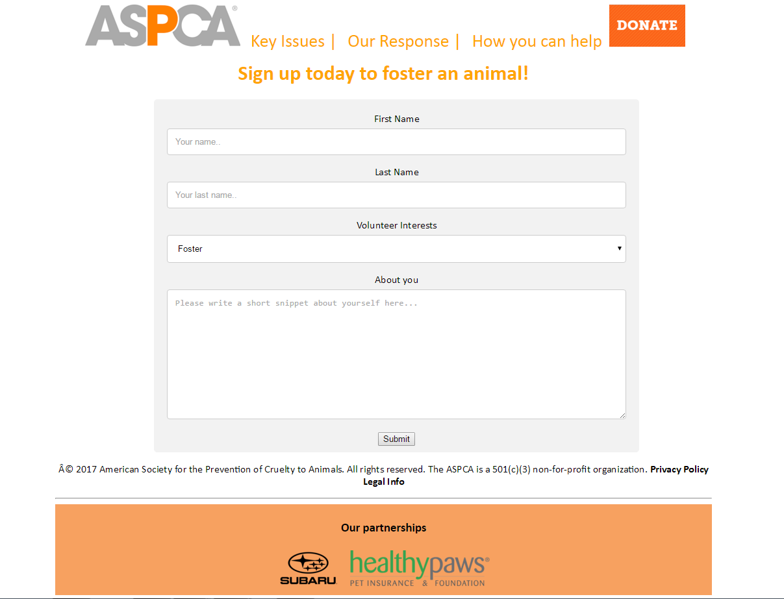**index.html WITH CSS:**

**key_issues.html WITH CSS:**

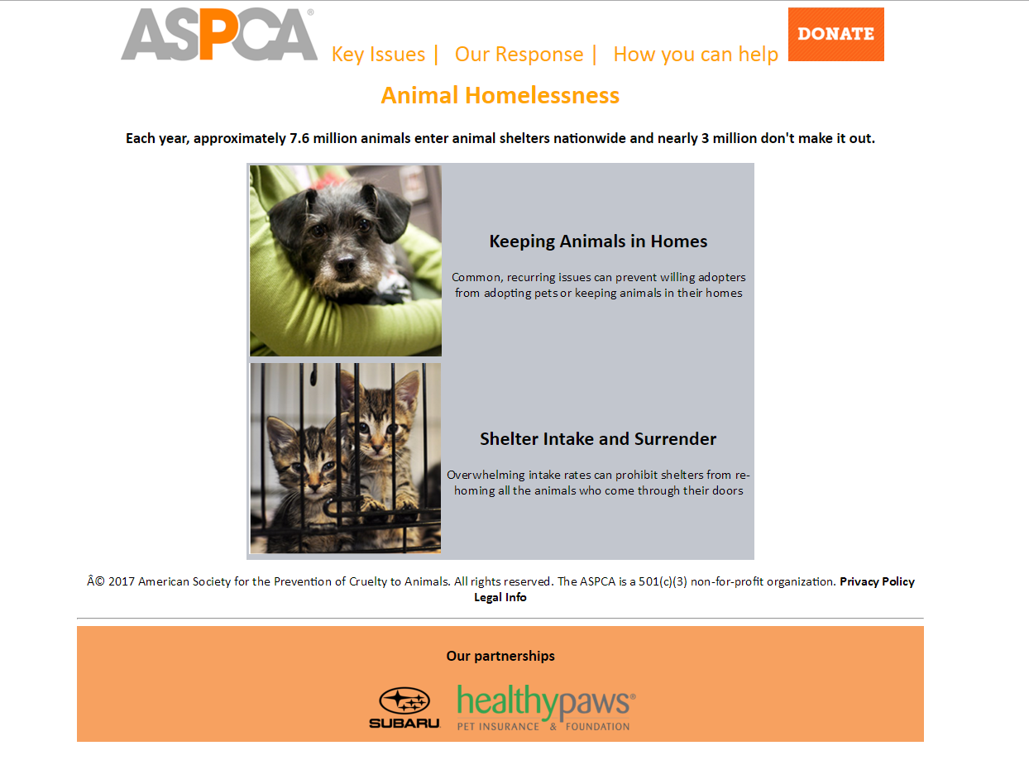

**our_response.html WITH CSS:**

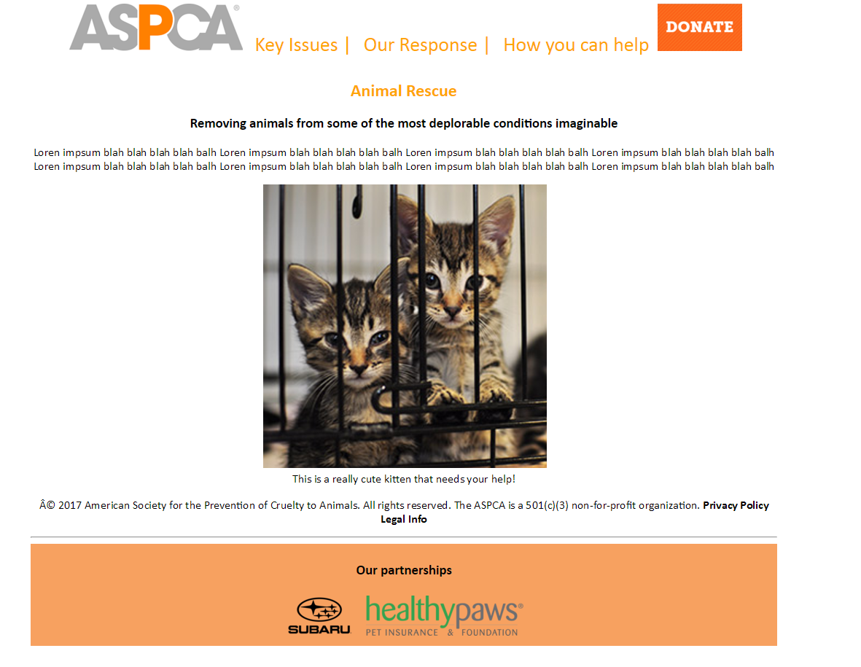

**how_you_can_help.html WITH CSS:**



Content of your choice

# Congrats! You have completed your first *beautiful* website using HTML + CSS! ☺

## Pat yourself on the back!

LAST MODIFIED: Nov 6, 2018